

Changing Lives Through learning

**Student Name-Simranjit Kaur**

**REPORT START**

# Client Details

My assignment is related to gym clubs. It display information about different gyms, activities.

|  |  |
| --- | --- |
| Website Name | 24 Fitness MVC |
| Address | 16 b Philip street Papatoetoe |
| Phone Number | 0225477062 |
| Email Address | Sk6741486@gmail.com |
| website creater | Simranjit Kaur |

# Project scope

## Purpose

The main purpose of the website is to attract customers to come the in Gym. This website is very simple and attractive. People can follow it easily. This website can be used with all browsers like opera browser, safari, Google chrome, internet explorer, Firefox.

## Goals

* Attracts customers

This website has lot of knowledge about gym Activities with good colour schema and visible content. It looks very beautiful and help to improve the interest of costumer.

* Knowledge of Packages

This assignment gives the knowledge about the different Packages of Gym

## Features

* Online Register

People can register online

Awareness of the customer

This website can aware the customer by creating the profile on the website.

* Information about location

People can search the location easily through of the website.

* Customers details

The website also gives the information to the customer like their phone number, Address, e-mail id.

## Target audience

* Men
* Women
* Unisex

# Visual Planning

1. **Home page**

This page gives the information about Gym it appears the picture which attract the customers about join gym.

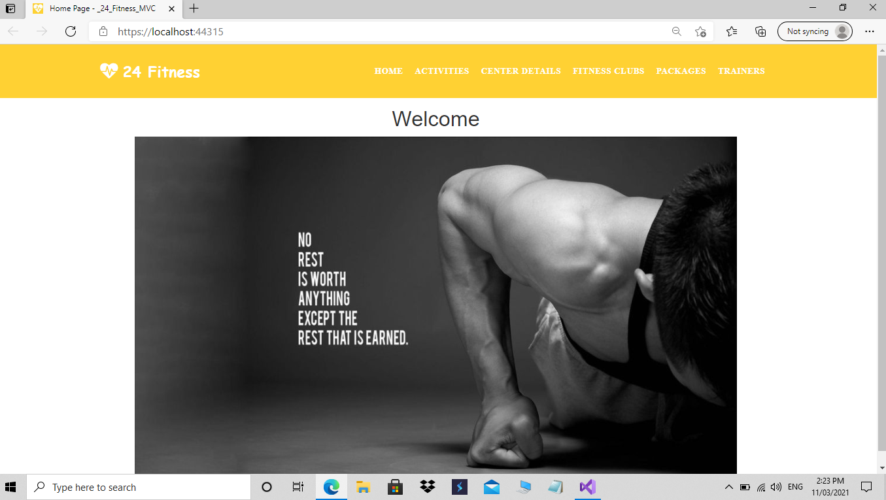

1. **Activities Page**

This page displays the information about different activities in the gym like cardio, cycling, and many others.

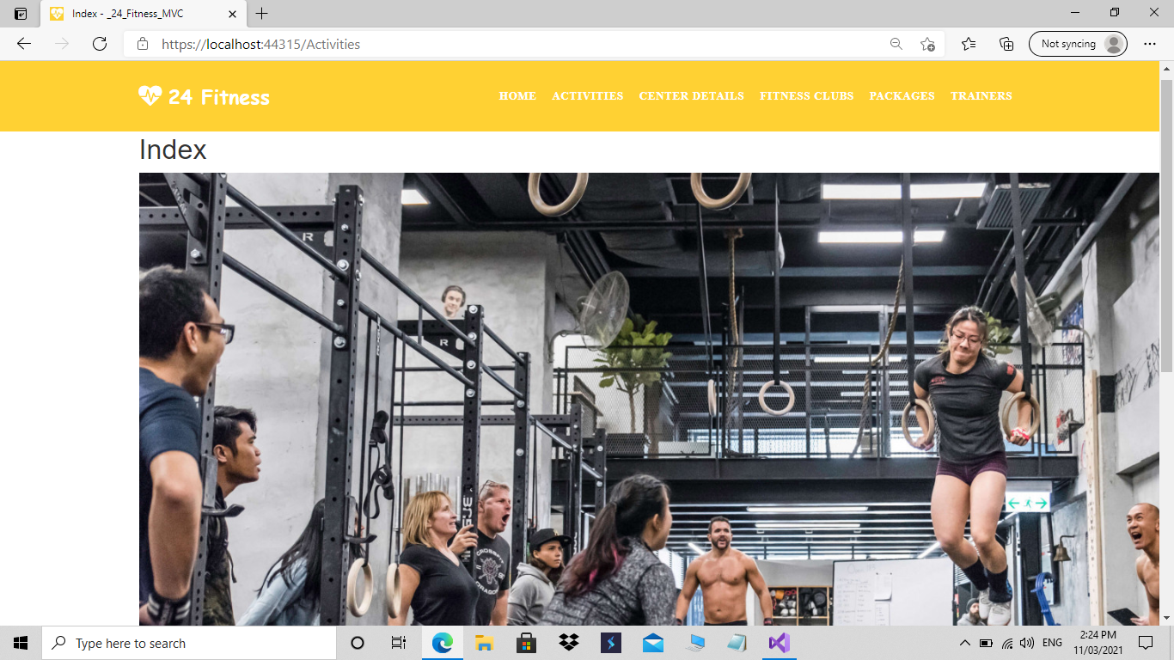

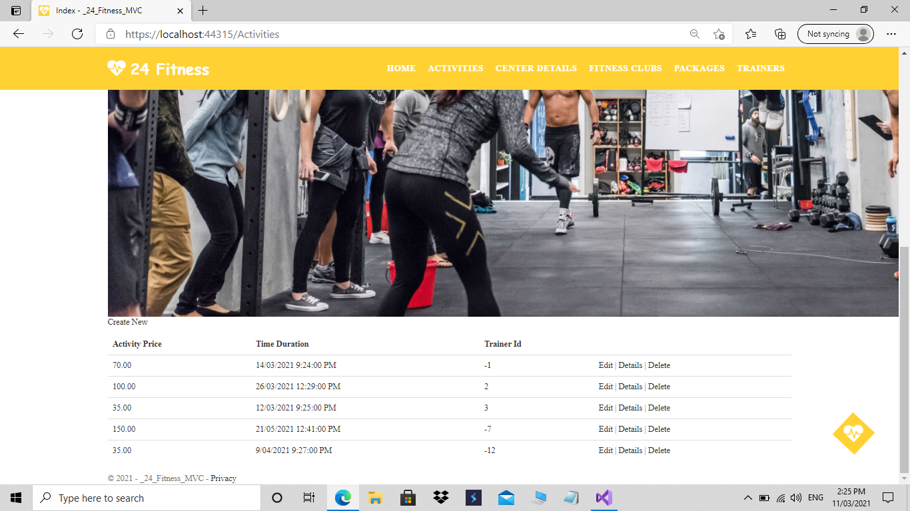

**3 Centre details**

**This page gives the information about different centres which provides the different packages on different times and special offers. Its good part to attract customers.**

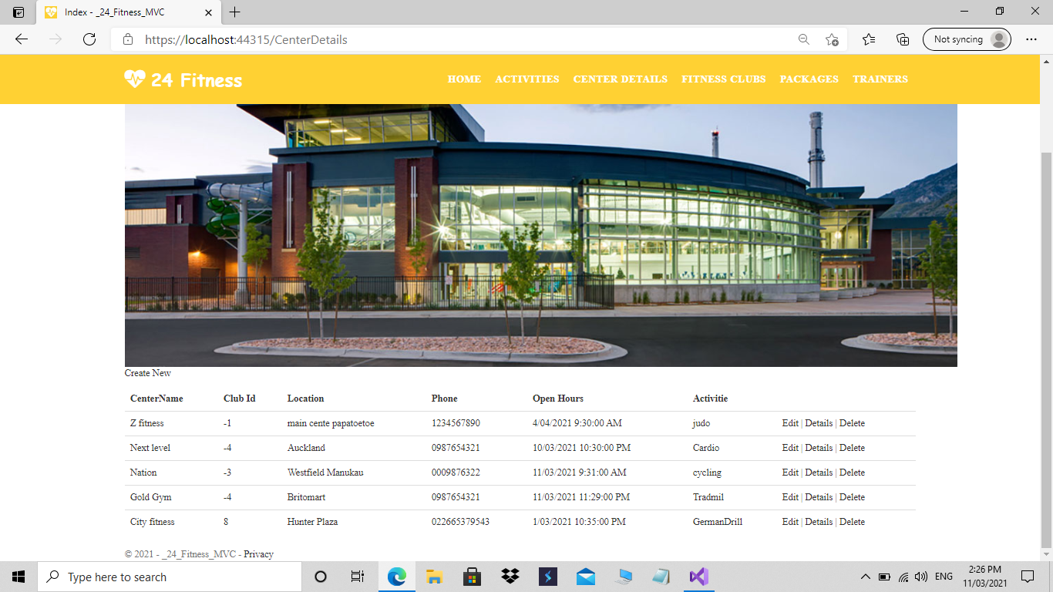

4. **Packages**

**Package page shows the information about different yearly, monthly packages on different prices.**

**5.Fitness Club**

The NEXT PAGE is hotels. This page includes the information of the hotels details which shows the available services in the hotel. The website describes contrast from the design principals by its simple design.

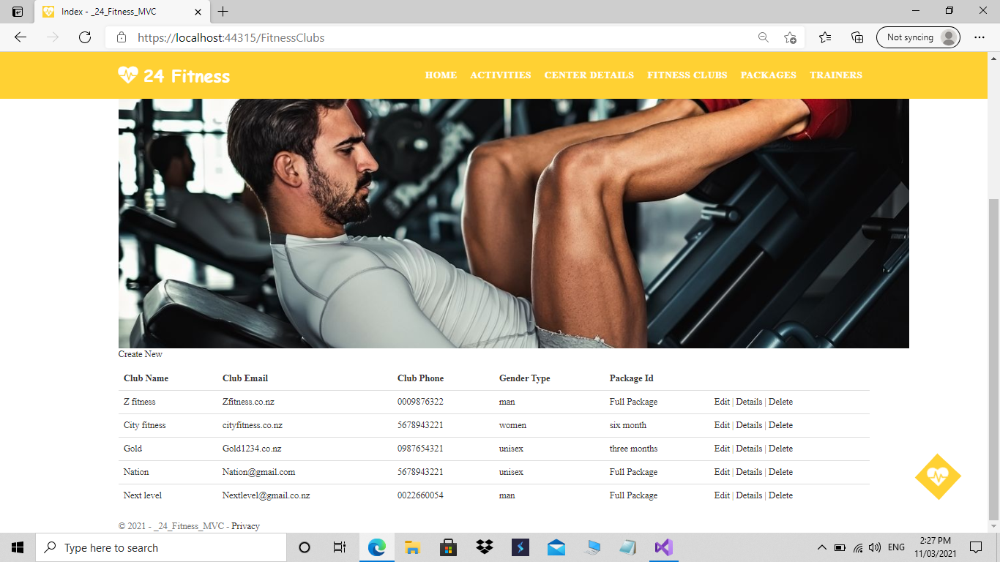

**5.Trainer**

**Trainer pages reflect the information about trainers like five trainers. They are related to different activities.**

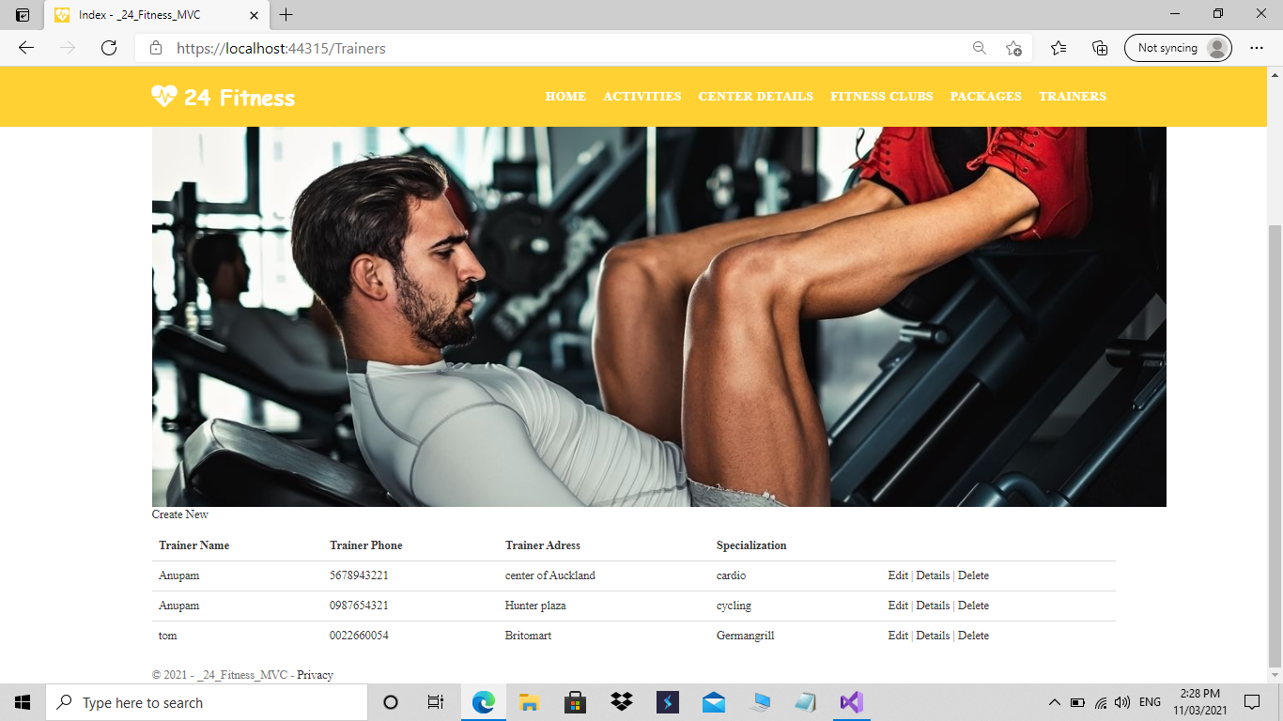

### Fonts

|  |  |  |
| --- | --- | --- |
| Font style | Font family | Used for |
| Calibri light (Headings) | Sans serif | Headings |
| Calibri (Body) | Sans serif | Information |
|  |  |  |

Based on the name of New Zealand.

# Tasks Detail

Here you need to provide the Gantt chart with all tasks, estimate time for each task and total time estimation.

|  |  |  |
| --- | --- | --- |
| Weeks | Tasks | Time |
| 1 | Client details  Purpose  Goals  Features  Target audience | 60 minutes  20 minutes  20 minutes  20 minutes  20 minutes |
| 2 | Appearance and style  Page contact details  Wireframes  Sitemap  Domain names  Web hosting details | 50 minutes  140 minutes  60 minutes  20 minutes  40 minutes  20 minutes |
| 3 | Testing  Grammar, spellings ,links | 150 minutes |
|  | Total timing | 12 hr |

# Domain Names

The website used for NEW ZEALAND has some domain names which customer can use to open the website.

|  |  |
| --- | --- |
| No. | Domain names |
| 1 | [www.nation.co.nz](http://www.nation.co.nz) |
| 2 | www.nz group.co.nz |
| 3 | <https://nz,co.nz> |

# Web Hosting Companies Detail

The website used for the NEW ZEALAND has different hosting web companies like Host Papa, Blue host, register.com.

|  |  |  |
| --- | --- | --- |
| Number | Web Hosting Company Name | Price |
| 1 | Host Papa | Starting at $ 3.95 per month |
| 2 | Blue host | Starting at $ 4.18 per month |
| 3 | Register.com | Starting at $ 5.95 per month |

**REPORT ENDS!**